**VISVESVARAYA TECHNOLOGICAL UNIVERSITY**

**BELGAUM**

**A Mini Project Report On**

**“Restaurant Portfolio Website”**

**Submitted in partial fulfilment of the requirements for the award of the 5thsem of**

**BACHELOR OF ENGINEERING**

**IN**

**INFORMATION SCIENCE AND ENGINEERING**

**Submitted by:**

**JEET ROY KUMAR SHIVAM SANKET BANERJEE SIDHARTH N**

**[1VE18IS022] [1VE18IS019] [1VE18IS043] [1VE18IS048]**

**Under the guidance of**

**Mrs.PANKAJA R**

**Asst. Prof, Dept. of ISE**



**DEPARTMENT OF INFORMATION SCIENCE AND ENGINEERING-**

**SRI VENKATESHWARA COLLEGE OF ENGINEERING**

Affiliated to VTU Belgaum & Approved by AICTE New Delhi) an ISO 9001: 2008 Certified Kempegowda International Airport road, Vidyanagar, Bengaluru, Karnataka, India-562157

**2020-2021**

**SRI VENKATESHWARA COLLEGE OF**

**ENGINEERING**

(Affiliated by A.I.C.T.E and approved by V.T.U)



**CERTIFICATE**

This is to certify that WEB TECHNOLOGY mini project [18] work entitled **“Restaurant Portfolio Website”** submitted in partial fulfilment of the requirement for VI semester bachelor of engineering in Information science and engineering prescribed by the **Visvesvaraya Technological University, Belgaum** is a result of the Bonafede work carried out by **Sanket Banerjee [1VE18IS043], Sidharth N [1VE18IS048], Jeet Roy [1VE18IS019], Kumar Shivam [1VE18IS043]** during the academic year **2020-21.** It is certified that all corrections/suggestionsindicated for Internal Assessment have been incorporated in the Report deposited in the departmental library. The project report has been approved as it satisfies the academic requirements in respect of Project work prescribed for the said Degree.

**............................................... ............................................**

**Signature of Course Teacher**  **Signature of HOD**

**Mrs. Pankaja R Dr. SHOBA M**

**Asst. Prof, Dept. of ISE Dept. of ISE**

**SVCE, Bangalore SVCE, Bangalore**

**Name of the examiners: Signature with date**

1: ................................................. .................................................

2: ................................................. .................................................

**ACKNOWLEDGEMENT**

The satisfaction and euphoria that accompany the successful completion of any task would be incomplete without complementing those who made it possible, whose guidance and encouragement made our efforts successful.

My sincere thanks to highly esteemed institution SRI VENKATESHWARA COLLEGE OF ENGINEERING for grooming up me in to be software engineer.

We express our sincere gratitude to Dr. SURESHA, Principal, SVCE, Bengaluru for providing the required facility.

We are extremely thankful to Dr. SHOBA M, HOD of ISE, SVCE for providing support and encouragement.

We are grateful to Mrs. PANKAJA R, Asst. Professor, Dept. of ISE, SVCE who helped me to complete this project successfully by providing guidance, encouragement and valuable suggestion during entire period of the project. I thank all my computer science staff and others who helped directly or indirectly to meet my project work with grand success.

Finally, we are grateful to my parents and friends for their invaluable support guidance and encouragement.

JEET ROY KUMAR SHIVAM SANKET BANERJEE SIDHARTH N

[1VE18IS043] [1VE18IS019] [1VE18IS043] [1VE18IS048]

**DEPARTMENT VISION**

Global Excellence with Local relevance in Information Science and Engineering Education, Research and Development.

**DEPARTMENT MISION**

M1) Strive for academic excellence in Information Science and Engineering through student centric innovative teaching-learning process, competent faculty members, efficient assessment and use of ICT.

M2) Establish Centre for Excellence in various vertical of Information Science and Engineering to promote collaborative research and Industry Institute Interaction.

M3) Transform the engineering aspirants to socially responsible, ethical, technically competent and value added professional or entrepreneur.

**ABSTRACT**

The purpose of the project is to develop a web application which is user friendly simple, fast, and cost–effective. It deals with the collection of food dishes available in a restaurant. Traditionally, it was done manually. The main function of the app is to create, edit and retrieve the details of food dishes and also to manipulate these details meaningfully. This website is accessible to the users who wants to view the restaurant and dishes severed. Only user can view and post comments and feedback into the website. The data can be retrieved easily. The data are well protected for personal use and makes the data processing very fast.

**CONTENTS**

**Chapter no. Page no.**

1. Introduction 1

1.1 Objectives

1.2 Project Module

2. Tech Stack 2

2.1 Front End

2.2 Back End

3. Project Design 3

3.1 Operations Performed

4. Implementation 4

4.1 Source Code

5. Snapshots 6

7. Conclusion and Future Enhancement 10

8. References 10

**Chapter 1**

**INTRODUCTION**

* 1. **Overview**

This is a restaurant portfolio website where the restaurant can showcase their different dishes and customers can write comments and feedbacks on the website.

* 1. **Project Module**

The website contains 5 webpages:

1. Home page
2. About Us page
3. Menu Page
4. Dish Detail Page
5. Contact Us Page

**Chapter 2**

**Tech Stack**

**2.1 Front End:**

1. HTML
2. CSS
3. Bootstrap

**2.2 Back End:**

1. JSON Database
2. HTTP Server
3. Server Communication is promise based

The front end and back end are integrated by React (JS Framework).

**Chapter 3**

**PROJECT DESIGN**

* 1. **Operations Performed**
* Showcases all the dishes on the menu page dynamically.
* The website has many animation and on scroll animations have also been added.
* It has a rich UI/UX which provides a good browsing experience.
* Viewers of the website can post comments on the selected dish.
* Viewers can send their feedback and the feedback is recorded.

**Chapter 4**

**IMPLEMENTATION**

**4.1 Source Code**

import React, { Component } from ‘react’;

import Home from ‘./homeComponent’;

import Header from ‘./headerComponent’

import Footer from ‘./footerComponent’

import Menu from ‘./menucomponent’;

import DishDetail from ‘./dishdetailcomponent’;

import Contact from ‘./ContactComponent’

import About from ‘./AboutComponent’

import { Switch, Route, Redirect, withRouter } from ‘react-router-dom’

import { connect } from ‘react-redux’;

import { postComment, fetchDishes, fetchComments, fetchPromos, fetchLeaders, postFeedback } from ‘../redux/ActionCreaters’

import { actions } from ‘react-redux-form’

const mapStateToProps = state => {

return{

dishes: state.dishes,

comments: state.comments,

leaders: state.leaders,

}

}

const mapDispatchToProps = (dispatch) => ({

postComment: (dishId, rating, author, comment) => dispatch(postComment(dishId, rating, author, comment)),

fetchDishes: () => {dispatch(fetchDishes())},

resetFeedbackForm: () => {dispatch(actions.reset(‘feedback’))},

fetchComments: () => {dispatch(fetchComments())},

fetchLeaders: () => {dispatch(fetchLeaders())},

postFeedback☹values)=>postFeedback(values),

})

class Main extends Component {

constructor(props){

super(props);

}

componentDidMount(){

this.props.fetchDishes();

this.props.fetchComments();

this.props.fetchLeaders();

}

render() {

const DishWithId = ({match}) => {

return(

<DishDetail dish={this.props.dishes.dishes.filter((dish) => dish.id === parseInt(match.params.dishId,10))[0]}

isLoading={this.props.dishes.isLoading}

errMess={this.props.dishes.errMess}

comments={this.props.comments.comments.filter((comment) => comment.dishId=== parseInt(match.params.dishId,10))}

errMess={this.props.comments.errMess}

postComment={this.props.postComment}

/>

);

}

return (

<div>

<Header />

<Switch>

<Route path=”/home” component={Home} />

<Route path=”/aboutus” component={() => <About leaders={this.props.leaders} />} />

<Route exact path=”/menu” component={() => <Menu dishes={this.props.dishes} />} />

<Route path=”/menu/:dishId” component={DishWithId} />

<Route path=”/contactus” component={() => <Contact resetFeedbackForm={this.props.resetFeedbackForm} postFeedback={this.props.postFeedback}/>} />

<Redirect to=”/home” />

</Switch>

<Footer />

</div>

);

}

}

export default withRouter(connect(mapStateToProps, mapDispatchToProps)(Main));

**Chapter 5**

**SNAPSHOTS**

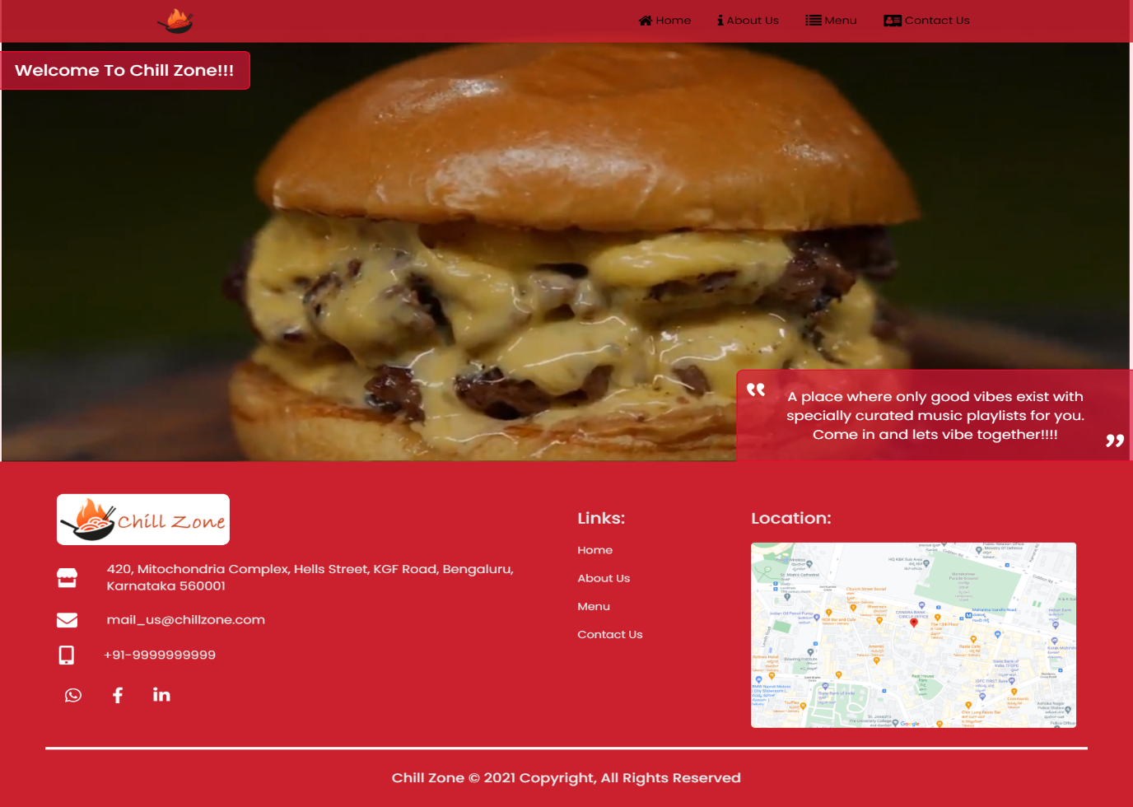

Home Page

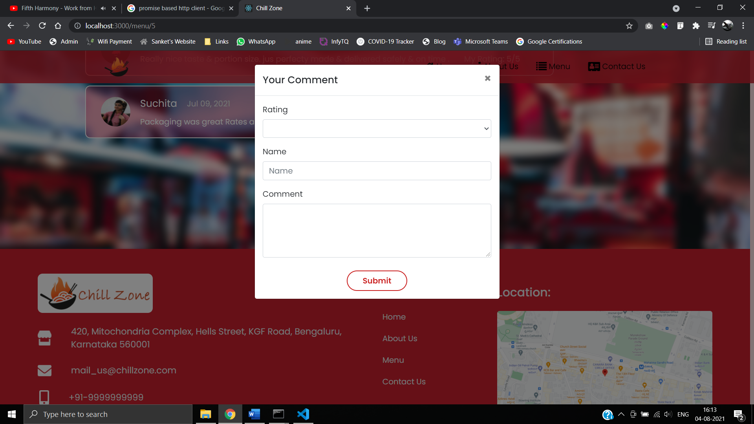

Posting Comments Section

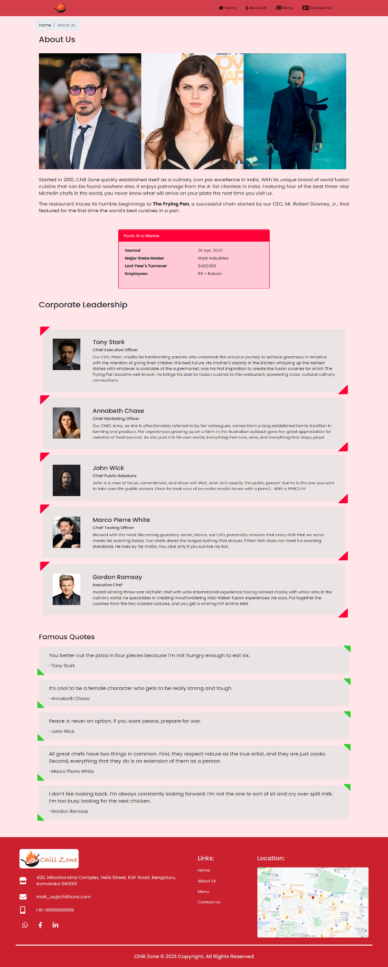

About Us Page

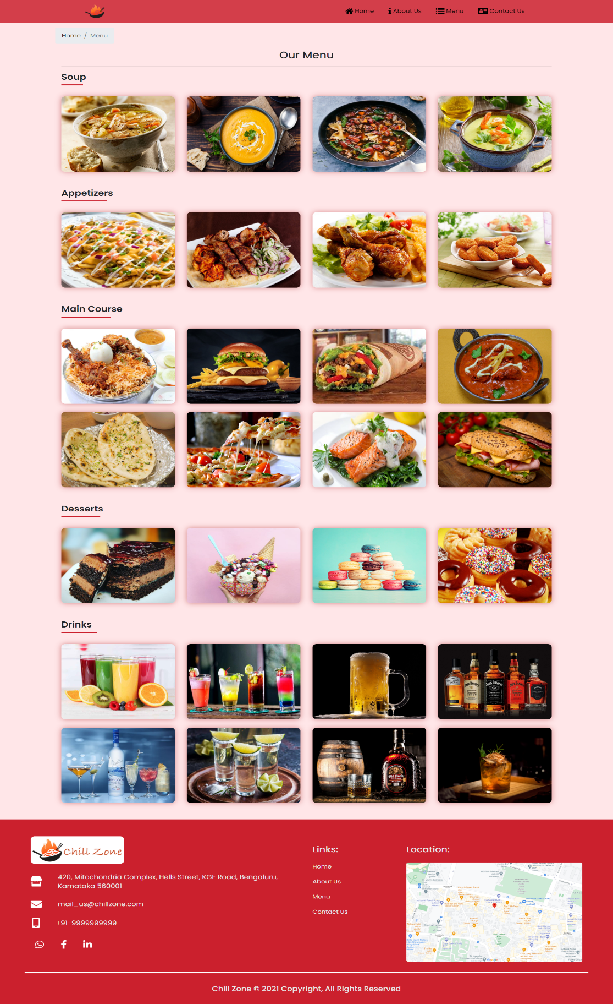

Menu Page

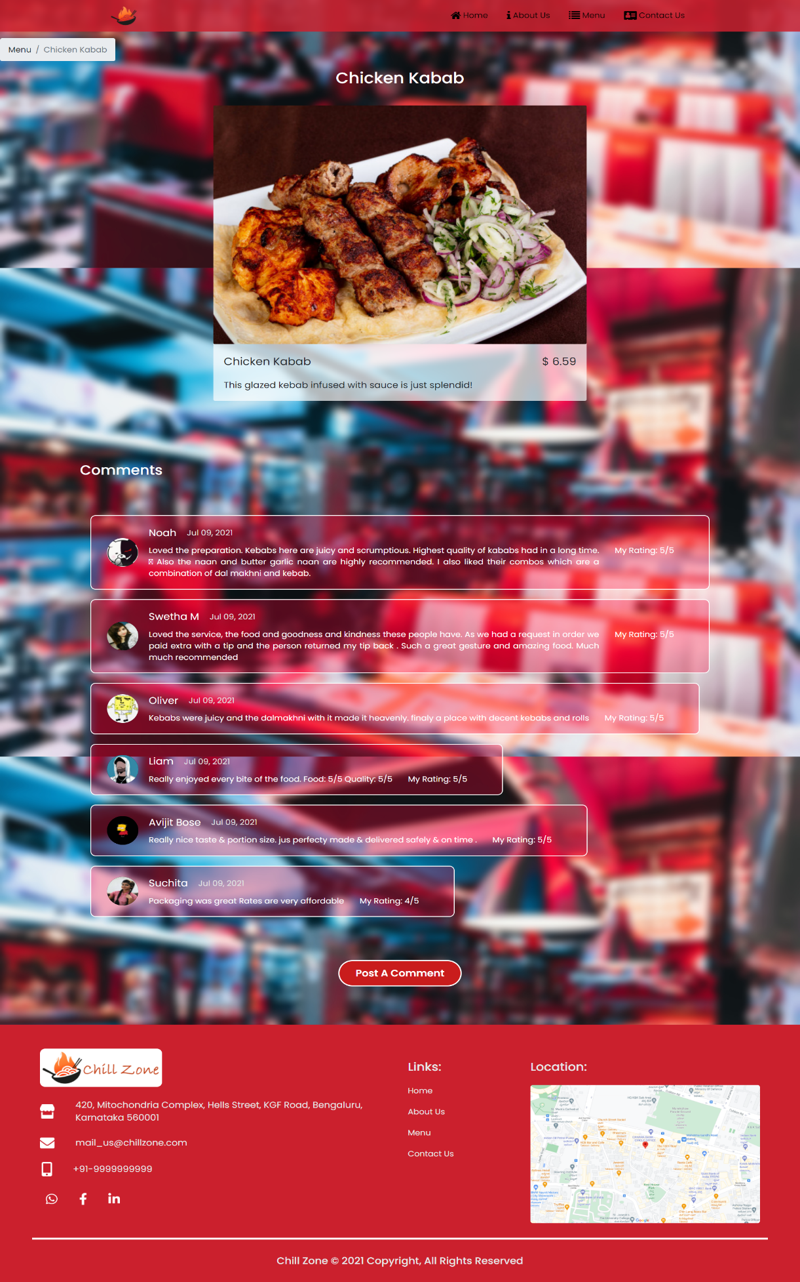

Dish Detail Page

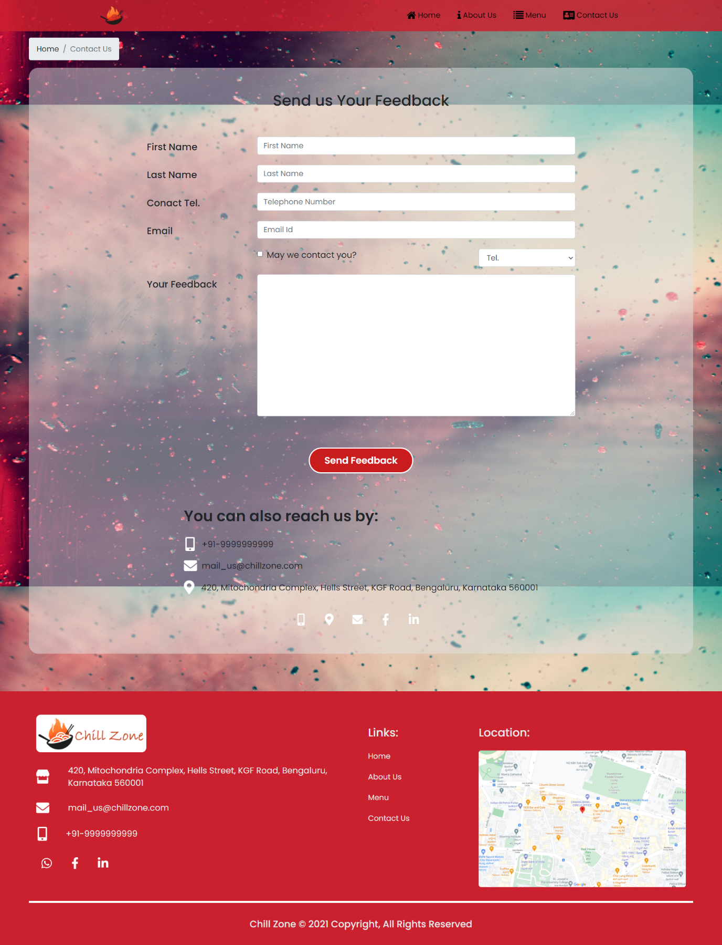

Contact Us Page

**Chapter 6**

**CONCLUSIONS**

This website is for made for customers to view different dishes, check out the restaurant brand, post comments and send feedbacks. The website has a rich UI and UX to make it user friendly. The restaurant owner can even add more dishes by updating the database. Animation on scroll is used in all pages to enhance the user experience.

**FUTURE ENHANCEMENT**

* More Menu Items can be added.
* Creating an admin panel to add new dishes to the menu.
* Creating a login system.
* Creating a table reservation system.

**REFERENCES**

* W3 Schools (https://www.w3schools.com/w3css/defaulT.asp)
* Stack Over Flow (Debugging and error solutions)
* Coursera (React Tutorial)
* Animation On Scroll Library for React (https://michalsnik.github.io/aos/)